Residency Day 1: Project 1: Secure Software Design
University of the Cumberlands
MSCS-535 Secure Software Development
2026 Spring
March 27, 2026

Phishing Attack, SQL Injection Vulnerability, and Secure Prevention
This project demonstrates a full security scenario involving a phishing attack followed by a SQL injection vulnerability and its prevention. The objective is to illustrate how attackers exploit human behavior and insecure coding practices, and how secure design principles mitigate these risks.
Phishing Attack Scenario
The attack begins with a phishing email sent to employees, impersonating the IT department and requesting credential verification.
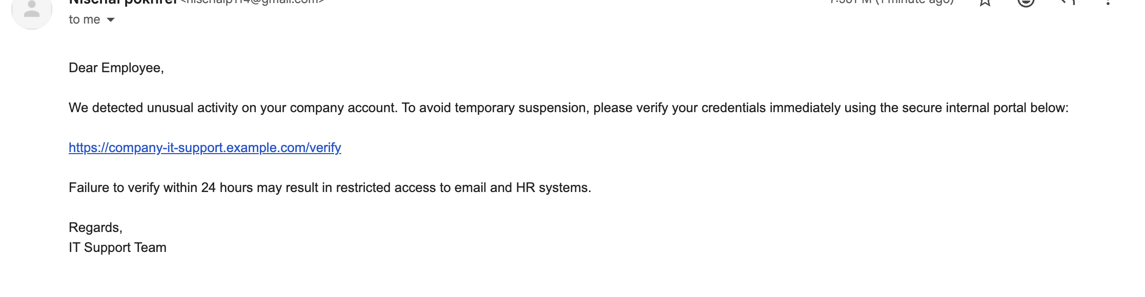
SQL Injection Attack Demonstration
The attacker then exploits a vulnerable web application that directly concatenates user input into SQL queries. By injecting malicious input, the attacker bypasses authentication.
Figure 1
SQL Injection attack successfully bypassing login authentication.
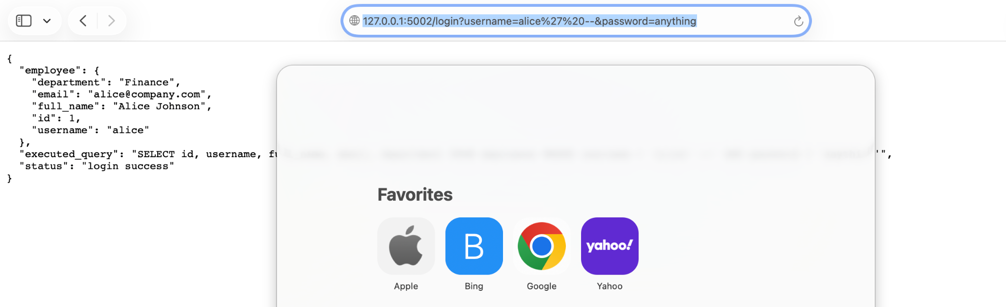
Secure Implementation and Prevention
The secure version of the application prevents SQL injection by using parameterized queries. User input is treated as data rather than executable SQL. Additionally, HTTPS is used to encrypt communication.
Figure 2
Secure application blocking SQL injection attack over HTTPS.
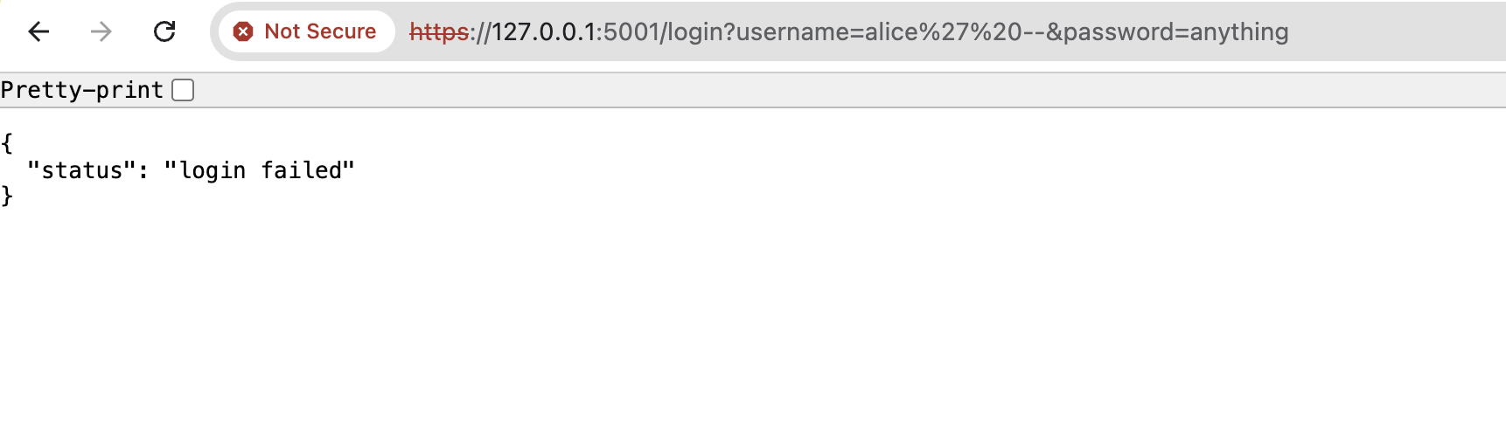
Conclusion
This project demonstrates how a phishing attack can lead to credential compromise and how insecure applications can be exploited using SQL injection. However, by implementing parameterized queries and HTTPS, the system effectively prevents such attacks, ensuring secure data handling.
References
American Psychological Association. (2020). Publication manual of the American Psychological Association (7th ed.).

